Tibberton & Cherrington Parish Council
www.tibbertonandcherringtonpc.org.uk
Chairman of the Council  Cllr Nick Eyles | Clerk to the Council  Claire Chapman

Minutes of the Annual General Parish Council meeting of
Tibberton and Cherrington Parish Council held at Tibberton Church at 7:00pm on Monday 11th May 2026.
Members present: Cllrs: Eyles (Chairman), Berry (vice Chairman), Arnot, Burrell, Good, and Stubbs.
In attendance: Claire Chapman (Clerk)
Public Session –
The meeting was opened to residents of the parish to raise issues of interest or concern. The signage for Millers Gate has remained and this will be chased up.
A request to position an ‘unknown Tommy soldier’ statue on the land by the Tibberton noticeboard was considered. More information and clarification to be sought.
26/01 Election of Chair and Vice-Chair of the Parish Council
a) Cllr Berry proposed Cllr Eyles remain as Chair, seconded by Cllr Stubbs, and agreed.
Cllr Good proposed Cllr Berry as Vice Chair, seconded by Cllr Arnot, and agreed.
b) Confirmation of no vacancies and no Co-opt applications were presented. .
Cllr Eyles reminded all Councillors of the Code of Conduct standards expected and all agreed unanimously.

26/02 Apologies
Apologies were received from Cllr Parkes. Cllr Burrell had a conflict of meetings and had confirmed he would attend late.
26/03 Declarations of interest
All councillors were asked by the Clerk to sign their declarations of interest, and acceptance of office and confirm they had no conflicts of interest for items on the agenda. No declarations of interest for the agenda were declared.
26/04 Audit Committee 2026-27
All Councillors were asked to express their interest in being the Chair or a member of the Audit Committee for 2026-27. Cllr Eyles proposed Cllr Good as chair, and this was seconded by Cllr Berry and agreed. Members of the Audit Committee were agreed, Cllrs Arnot, Eyles, Good and Stubbs.

26/05 To consider for adoption the draft minutes of the Annual Parish Council Meeting and AGM 19th May 2025 and for the meeting of the 9/3/2026.
The draft Minutes of the AGM Meeting, Monday 19th May 2025 and Meeting 9/3/2026 had been circulated prior to the meeting.
The adoption of all Minutes was proposed by Cllr Arnot, seconded by Cllr Berry, and agreed.
26/06 Finance Report

- To adopt the Annual Accounts 2025-26. The accounts had been circulated prior to the meeting. Cllr Good proposed that the Council adopt the accounts and this was seconded by Cllr Arnot and agreed.
- Internal Audit: To consider the findings of the review of the effectiveness of the Council’s system of internal control Katrina Baker (The Internal auditor) has completed her audit. The Chair shared that there were no formal recommendations and shared the report findings acknowledging the effectiveness of systems. Cllr Good proposed that the Council receive and accept the report and this was seconded by Cllr Arnot and agreed.
- To approve the Annual Governance Statement 2025-26. The Statement had been circulated prior to the meeting.
- To consider and approve the Accounting Statements for 2025-26 The Accounting Statements had been circulated prior to the meeting.
- To confirm the Parish Council wishes to certify as exempt from a limited assurance review under Section 9 of the Local Audit (Smaller Authorities) Regulations 2015).
- Asset Register: To confirm the Council’s Asset Register. Circulated prior to the meeting.
- Standing Orders: To confirm the Council’s Standing Orders. Circulated prior to the meeting.
- Financial Regulations: To confirm the Council’s Financial Regulations. An updated 2024 Regulations had been circulated.

Cllr Good proposed that items c-h be considered together, and this was seconded by Cllr Arnot.

- Clerk’s salary; as per the decision January 2026 to approve all payments for 2026-27, proposed by Cllr Eyles and seconded by Cllr Stubbs
- 1 Item to pay were considered, proposed by Cllr Eyles and seconded by Cllr Stubbs.

Details | Amount  £
SALC fees | £560.59

- Cheque signatories were reviewed and confirmed, Cllr Eyles, Berry and Good.

26/07 Planning matters
Planning Application Number, Location & Proposed Development
TWC/2026/0244 – no objections raised by Council.
Cornerstone House, Plantation Road, Tibberton, Newport, Shropshire, TF10 8PD
Erection of a portico, installation of 2no. windows to existing porch/hall and widening of the existing entrance door
TWC/2026/0268 – no objections raised by Council.
2 Clark Croft, Tibberton, Newport, Shropshire, TF10 8EZ
Erection of a single storey rear extension and installation of log burner with associated metal flue

TWC/2026/0144 – Full Granted
8 Orchard Grove, Tibberton, Newport, Shropshire, TF10 8EY
Erection of a single storey rear extension, installation of a front porch, installation of 1no. window, creation of a first floor to existing garage and associated installation of 2no. external doors and external stairs and installation of solar panels to the front elevation roof of existing garage

TWC/2026/0060 – Full Granted
Manderley, 6 Anvil Close, Tibberton, Newport, Shropshire, TF10 8PT
Erection of a single storey side and rear extension

25/03608/FUL – Ongoing
Land Adjacent Wood Farm Caynton Newport Shropshire
Erection of a free-range egg production unit and associated infrastructure

26/08 Outstanding Items

Logo – Cllr Eyles confirmed that work was progressing, and work had been commissioned to digitalise the design which would be ready for July meeting.
Condition of Trees– concern was voiced given the recent unfortunate death of a schoolboy in Stafford. Cllr Burrell confirmed that he continued to progress this and a date for a site meeting is to be confirmed. Carried Forward.
Road usage – Cllr Eyles has a meeting with Highways in the next few weeks and will ensure this is part of the discussions along with other items Carried forward.
Footpaths– the Clerk confirmed that this would require a grant application, acknowledgement of some improvement work already undertaken within the Parish.
Relocation of Waste Bins – Cllr Eyles confirmed that he had met TWC and that the quote had been agreed and TWC are arranging to move the bin and install bollards on the field.
Quality of Road conditions – Cllr Eyles confirmed work on the main entrance to the village was anticipated during qtr 1 and that the bus route would be diverted to turn around at Maypole and return up Back Lane during this works. Cllr Burrell shared that Balfour Beatty had been appointed and work was currently anticipated for June 2026. Cllr Burrell set out that planned diversions were looking at Back Lane and signage was requested to reduce heavy vehicles using Hay Street during this works.
Potholes – Cllr Eyles shared his frustration that repairs were being repeated numerous times and failing within weeks, he has photographed and reported all potholes on Back Lane and the main access road.
Facilities on school field – Cllr Burrell set out that while he recognised the frustration of parishioners and Council alike for delays to visible progress – he was keen to ensure that he secured full agreement from TWC for a viable plan for the demolition, removal of the existing pavilion alongside the provision of new facilities.

26/09 AOB

Cllr Eyles shared an update on a local Butterfly and Moth project which included walks and talks – all dates and information will be provided on noticeboards and the Parish Council website.
Cllr Eyles confirmed a new Severn Trent Flood team had contacted the Parish Council to introduce themselves and hear any concerns. Their focus is on natural flooding. The Parish Council agreed to invite them to the July meeting.
Cllr Eyles updated on changes to the Dogs protection of Livestock Act which have come into force. Definitions for livestock now include llamas and alpacas, and also for ‘worrying’. Maximum penalty limits are updated to unlimited with costs and powers increased. These powers include dogs that are on public land and Cllr Eyles encouraged all residents with dogs to familiarise themselves.
Cllr Stubbs confirmed that the new solar panel had been installed on the older Speed indicator device, however this was not sustaining battery capacity. He sought agreement to approach the owner of hedgerows at the point of the SID to seek a reduction in height to enable more sunlight. This was agreed.
Cllr Burrell updated following the public inspection of the TWC Local Development Plan confirming that he had spoken at two of the sessions. He confirmed that for any extension of development to be considered the Developer would need to present a convincing rationale and case. The next steps are that in September the report will be published followed by a further consultation and he anticipated that ratification by the Council will be around the end of 2026.
The Chair thanked Cllr Burrell for the update and for continuing to keep the Parish concerns visible throughout this period.

Cllr Eyles ended the meeting by acknowledging and recognising that Cllr Berry had completed 40 years’ service for the Parish Council in various roles over the years. Cllr Eyles presented Cllr Berry with a certificate and thanked him for all his service to date.
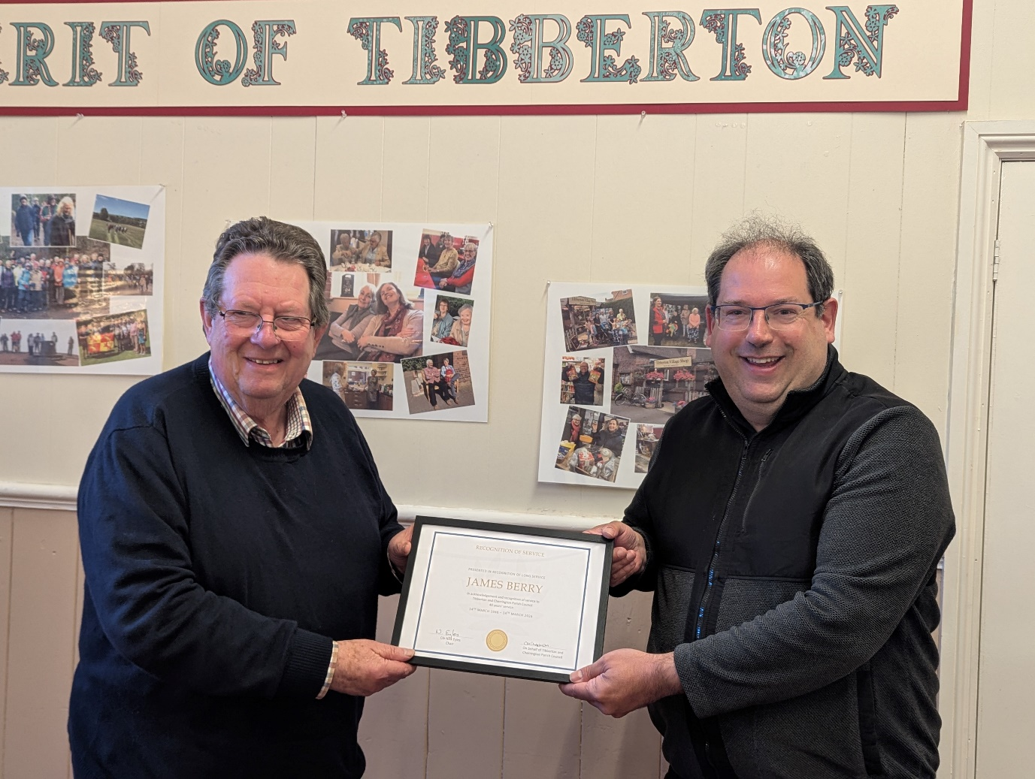

Date of next meeting Monday 13th July 2026 at 7.00pm in the Village Hall
Claire Chapman
Parish Clerk

